Algorithms for the chaturanga game bot/engine

function minimax(node, depth, isMaximizingPlayer, alpha, beta):

if node is a leaf node :
return value of the node

if isMaximizingPlayer :
bestVal = -INFINITY
for each child node :
value = minimax(node, depth+1, false, alpha, beta)
bestVal = max( bestVal, value)
alpha = max( alpha, bestVal)
if beta <= alpha:
break
return bestVal

else :
bestVal = +INFINITY
for each child node :
value = minimax(node, depth+1, true, alpha, beta)
bestVal = min( bestVal, value)
beta = min( beta, bestVal)
if beta <= alpha:
break
return bestVal

// Calling the function for the first time.
minimax(0, 0, true, -INFINITY, +INFINITY)

If $α≥β$ stop evaluating remaining children ($β$-cutoff)
Step 3:Min Node Evaluation
For each child of a Min node Recursively evaluate using Minimax with Alpha-Beta pruning Update Beta:
$$β=min(β,value)$$
If $β≤α$ stop evaluating remaining children ($α$-cutoff)

Implementation of Alpha-Beta pruning in Adversarial Search Algorithms
Here in this code we builds a game tree applies Alpha–Beta pruning to find the optimal minimax value and visualizes the traversal by marking visited edges in green and pruned edges in red.
Step 1: Install and import required libraries
- Importing essential libraries for graph visualization and manipulation.
- networkx is used to create and manage graph structures.
- matplotlib helps plot and display the generated graphs.
- pydot enables converting graph data into DOT format for clearer visual representations.

import matplotlib.pyplot as plt
import networkx as nx
import pydot
import io
Step 2: Define the Node class
- Node class is created to represent each state or node in a game/search tree.
- name stores the label or identifier of the node.
- children holds the list of child nodes, defaulting to an empty list if none are provided.
- value stores the evaluation score of the node, used in algorithms like Minimax
class Node:
def __init__(self, name, children=None, value=None):
self.name = name
self.children = children if children is not None else []
self.value = value
Step 3: Utility functions for evaluation and tree checks
- evaluate(node) returns the numeric value of a node, used for scoring terminal states.
- is_terminal(node) checks whether the node is a terminal state by verifying if it has an assigned value.
- get_children(node) retrieves all child nodes connected to the current node.
- These helper functions support tree traversal in algorithms like Minimax and Alpha-Beta pruning
def evaluate(node):
return node.value

def is_terminal(node):
return node.value is not None

def get_children(node):
return node.children
Step 4: Alpha–Beta pruning implementation with visit tracking
- Implements the Alpha-Beta pruning algorithm, recursively evaluating nodes while tracking visited and pruned edges.
- For Maximizing Player, it updates the best value found so far and raises alpha; pruning occurs when beta <= alpha.
- For Minimizing Player, it updates the minimum value and lowers beta; similarly prunes unnecessary branches.
- The visited_edges list stores both visited and cut edges, helping visualize the pruning process in a tree graph.
visited_edges = []

def alpha_beta_pruning(node, depth, alpha, beta, maximizing_player):
global visited_edges

if depth == 0 or is_terminal(node):
return evaluate(node)

if maximizing_player:
max_eval = float('-inf')
for child in get_children(node):
visited_edges.append((node.name, child.name, "visit"))
val = alpha_beta_pruning(child, depth - 1, alpha, beta, False)
max_eval = max(max_eval, val)
alpha = max(alpha, val)
if beta <= alpha:
visited_edges.append((node.name, child.name, "cut"))
break
return max_eval

else:
min_eval = float('inf')
for child in get_children(node):
visited_edges.append((node.name, child.name, "visit"))
val = alpha_beta_pruning(child, depth - 1, alpha, beta, True)
min_eval = min(min_eval, val)
beta = min(beta, val)
if beta <= alpha:
visited_edges.append((node.name, child.name, "cut"))
break
return min_eval
Step 5: Build an example game tree
- Leaf nodes D, E, F, G, H, I are created with fixed evaluation values, representing terminal states in the game tree.
- Nodes B and C group these leaves as their children and A becomes the root node, forming a complete multi-level game tree structure.
D = Node('D', value=3)
E = Node('E', value=5)
F = Node('F', value=6)
G = Node('G', value=9)
H = Node('H', value=1)
I = Node('I', value=2)

B = Node('B', children=[D, E, F])
C = Node('C', children=[G, H, I])
A = Node('A', children=[B, C])
Step 6: Visualizing the Game Tree with Alpha-Beta Output
- Alpha-Beta pruning is executed to compute the optimal value from the root node.
- A directed graph of the game tree is built by linking each node with its children.
- The graph is converted to DOT format using pydot for clean visualization.
- Matplotlib displays the final tree image, showing the full game structure.
best = alpha_beta_pruning(A, 3, float('-inf'), float('inf'), True)
print("Optimal Value =", best)

def build_graph(G, node):
for child in node.children:
G.add_edge(node.name, child.name)
build_graph(G, child)

G = nx.DiGraph()
build_graph(G, A)

g = nx.drawing.nx_pydot.to_pydot(G)
g.set_rankdir("TB")
png_str = g.create_png()

plt.figure(figsize=(8, 6))

plt.imshow(plt.imread(io.BytesIO(png_str)))
plt.axis("off")
plt.show()

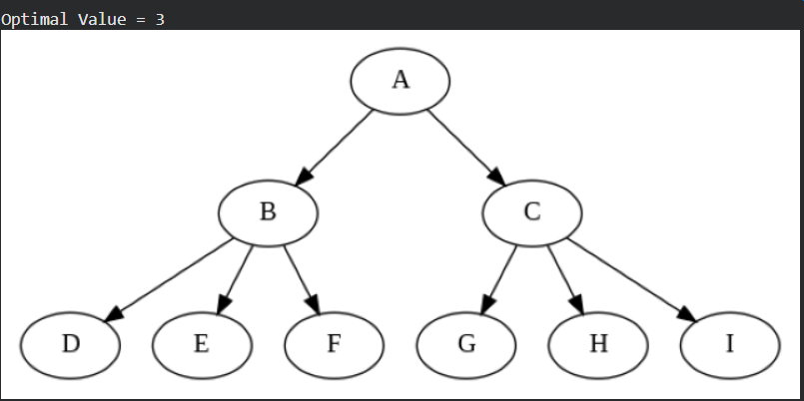
The image represents a game tree for Alpha–Beta Pruning with root node A. The algorithm computes the optimal value as 3 by pruning irrelevant branches.
Step 7: Visited and Pruned Edges in the Game Tree
- Each edge in the tree is checked against visited_edges to identify whether it was visited or pruned during Alpha-Beta pruning.
- Edges are color-coded: green for visited paths, red for pruned branches, and black for untouched edges.
- NetworkX and Graphviz are used to position and draw the tree with clear hierarchical layout.
- Matplotlib displays the final tree, visually showing how pruning reduces unnecessary exploration.
edge_colors = []
for u, v in G.edges():
status = None
for (s, d, t) in visited_edges:
if s == u and d == v:
status = t
break
if status == "visit":
edge_colors.append("green")
elif status == "cut":
edge_colors.append("red")
else:
edge_colors.append("black")

plt.figure(figsize=(10, 7))
pos = nx.nx_pydot.graphviz_layout(G, prog='dot')
nx.draw(G, pos, with_labels=True, arrows=False, node_size=2000,
node_color="lightblue", font_size=12, edge_color=edge_colors, width=3)
plt.title("Alpha–Beta Pruning (Green = Visited, Red = Pruned)")
plt.axis("off")
plt.show()

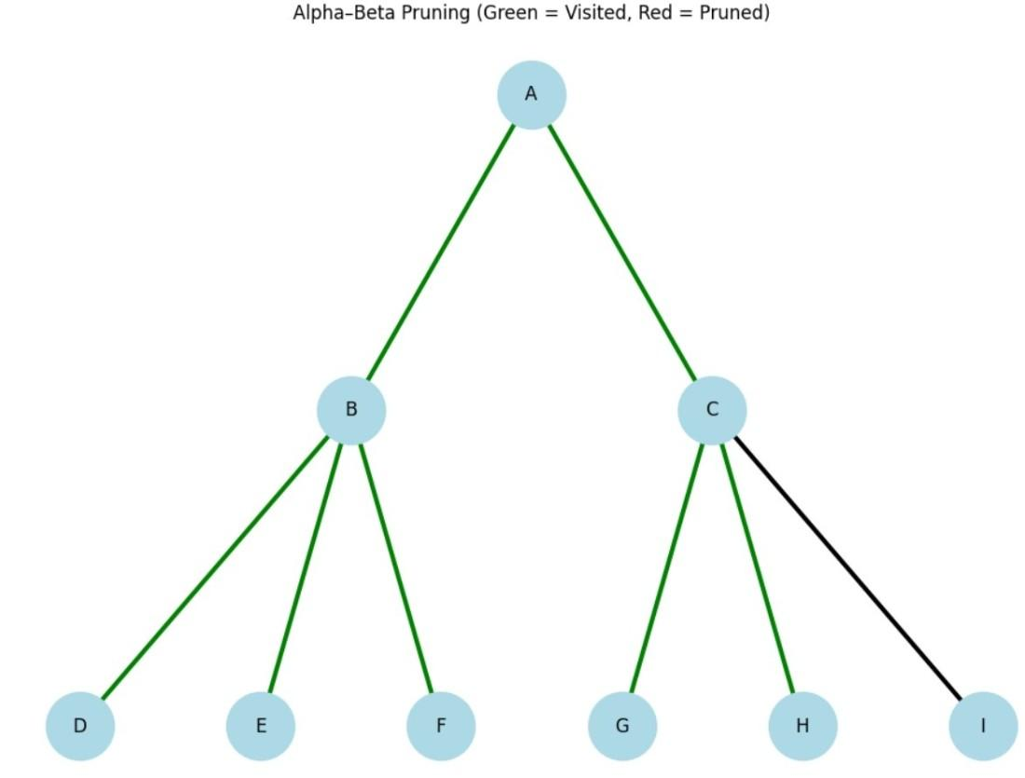

The Max-n algorithm is an extension of the Minimax algorithm designed for games with three or more players.
While standard Minimax handles two players (one maximizing and one minimizing a single value), Max-n treats every player as a maximizer of their own specific outcome.
Key Characteristics
- Perfect Information: It is typically used in finite games of perfect information to find an equilibrium point.
- Non-Zero Sum Flexibility: Unlike the two-player zero-sum Minimax, Max-n can be applied to non-zero-sum games where one player's gain isn't necessarily another's exact loss.
- Pruning Limitations: Standard Alpha-Beta pruning is much harder to implement in Max-n. Only "shallow pruning" is generally possible unless strict bounds on the sum of payoffs are known.
- Irrationality Risk: In games with 3+ players, a player’s strategy in Max-n is not guaranteed to be "perfect" if opponents play irrationally, as opponents can cooperate or make moves that hurt the current player without benefiting themselves.
Time Complexity: O(b^d)
Space Complexity:O(bd)
def max_n_4_player(state, depth, player_to_move):
"""
state: Current board/game configuration
depth: Look-ahead limit
player_to_move: Index (0, 1, 2, or 3)
"""
# 1. Base Case
if depth == 0 or state.is_terminal():
# Returns a 4-tuple: (p0_score, p1_score, p2_score, p3_score)
return state.evaluate_heuristic()

# 2. Initialization
# We want to maximize the payoff for 'player_to_move'
best_payoff_tuple = None
max_score = -float('inf')

# 3. Explore Moves
moves = state.get_legal_moves()
next_player = (player_to_move + 1) % 4

for move in moves:
child_state = state.apply_move(move)

# Recursive call returns payoffs for all 4 players
current_payoff_tuple = max_n_4_player(child_state, depth - 1, next_player)

# 4. Selection Logic
# Compare based ONLY on the current player's index in the tuple
if current_payoff_tuple[player_to_move] > max_score:
max_score = current_payoff_tuple[player_to_move]
best_payoff_tuple = current_payoff_tuple

return best_payoff_tuple

To adapt the Max-n algorithm for a four-player game with dice, you must incorporate Expectimax-N logic. This involves adding "Chance Nodes" that calculate the expected value (weighted average) of all possible dice outcomes for each player's payoff.
Implementation: Expectimax-N (4 Players + Dice)
This snippet alternates between Decision Nodes (where players choose moves) and Chance Nodes (where dice are rolled).

def max_n_with_dice(state, depth, player_index, num_players=4):
# 1. Base Case: End of search or game
if depth == 0 or state.is_terminal():
return state.get_payoffs() # Returns (p1_score, p2_score, p3_score, p4_score)

# 2. Chance Node: If the current state requires a dice roll
if state.is_chance_node():
# Initialize an empty tuple for average payoffs
expected_payoffs = [0.0] * num_players
outcomes = state.get_dice_outcomes() # e.g., list of (probability, next_state)

for prob, next_state in outcomes:
# Recurse for each dice outcome
result_tuple = max_n_with_dice(next_state, depth - 1, player_index)
# Weighted sum for each player's payoff
for i in range(num_players):
expected_payoffs[i] += prob * result_tuple[i]

return tuple(expected_payoffs)

# 3. Decision Node: Current player chooses the best move
best_tuple = (-float('inf'),) * num_players
next_player = (player_index + 1) % num_players

for move in state.get_possible_moves():
child_state = state.apply_move(move)
current_tuple = max_n_with_dice(child_state, depth - 1, next_player)

# Maximize the payoff for the player whose turn it is
if current_tuple[player_index] > best_tuple[player_index]:
best_tuple = current_tuple

return best_tuple

A heuristic evaluation/function calculates an estimated cost or score to guide decision-making in algorithms like A* search, often defined as $h(n)$
. It is designed to provide fast, sub-optimal answers by estimating the distance to a goal, such as using Manhattan distance ($\left|x_{1}-x_{2}|+|y_{1}-y_{2}\right|$) for grid-based pathfinding.
def heuristic_manhattan(current_node, goal_node):
"""
Estimates distance from current to goal node using Manhattan Distance.
"""
dx = abs(current_node[0] - goal_node[0])
dy = abs(current_node[1] - goal_node[1])
return dx + dy

# Usage
start = (0, 0)
goal = (5, 4)
# Estimated cost: 5+4 = 9
print(f"Heuristic Cost: {heuristic_manhattan(start, goal)}")

Key Characteristics of a Good Heuristic:
- Admissible: Never overestimates the actual cost to the goal (h(n)
$$≤$$
≤
actual cost).
- Consistency: The estimate is consistent if for every node $n$
and every successor $n^{'}$
generated by any action $a$
, the estimated cost of reaching the goal from $n$
is no greater than the step cost of getting to $n^{'}$
plus the estimated cost of reaching the goal from $n^{'}$
Example: Tic-Tac-Toe Evaluator
def evaluate_board(board):
"""
Evaluates a game state for a Tic-Tac-Toe agent.
Returns: +10 for win, -10 for loss, 0 for neutral.
"""
if check_win(board, "X"):
return 10
elif check_win(board, "O"):
return -10
return 0

Monte Carlo (MC) algorithm is a broad class of computational methods that rely on repeated random sampling to obtain numerical results. The core idea is to use randomness to solve problems that might be deterministic in principle but are too complex for direct analytical solutions.
1. How it Works
A typical Monte Carlo process follows these four steps:
- Define Input Domain: Identify the range of possible values for your uncertain variables.
- Generate Random Inputs: Draw samples from a specific probability distribution (e.g., Normal, Uniform, or Triangular).
- Perform Deterministic Computation: Run your model or calculation for each random sample.
- Aggregate Results: Combine the outputs to find an average, range, or probability of certain outcomes.
2. Classic Example: Estimating $π$
One of the most famous applications is estimating Pi by "throwing darts" at a square containing a circle.

import numpy as np
def estimate_pi(n_samples=100000):
# Generate random (x, y) coordinates between -1 and 1
x = np.random.uniform(-1, 1, n_samples)
y = np.random.uniform(-1, 1, n_samples)

# Check if points are inside the unit circle (x² + y² <= 1)
inside_circle = (x**2 + y**2) <= 1

# Ratio of points inside circle to total points = π / 4
pi_estimate = 4 * np.sum(inside_circle) / n_samples
return pi_estimate

print(f"Estimated Pi: {estimate_pi()}")
Use code with caution.
3. Key Applications
- Finance: Calculating Value at Risk (VaR) to predict potential losses in a portfolio.
- Engineering: Assessing the reliability of a structure by simulating various stress and material conditions.
- AI & Gaming: The Monte Carlo Tree Search (MCTS) helps AI make moves in complex games like Go or Chess by simulating thousands of "playouts" to see which path leads to victory.
- Physics: Simulating particle transport (like radiation) through different materials.
4. Advantages & Limitations
- Pro: It handles high-dimensional problems where other numerical methods fail (the "curse of dimensionality").
- Con: It is computationally expensive; accuracy improves only by the square root of the number of samples (e.g., to get 10x more accuracy, you need 100x more samples).

Decision tree algorithms are supervised learning methods that recursively split a dataset into branches based on feature values to make predictions. They are valued for their high interpretability, as their hierarchical structure mimics human decision-making and provides clear, rule-based logic for every outcome.
Core Decision Tree Algorithms
The evolution of decision trees is marked by three primary algorithms, each improving on how they select the best features to split data:
- ID3 (Iterative Dichotomiser 3): The foundational algorithm that uses Entropy and Information Gain. It primarily handles categorical data and is prone to overfitting if not carefully tuned.
- C4.5: An improvement over ID3 that handles both categorical and continuous variables. It uses the Gain Ratio to select splits, which prevents the algorithm from favouring features with too many unique values.
- CART (Classification and Regression Trees): The most modern standard, used by libraries like scikit-learn. It typically uses Gini Impurity for classification and Mean Squared Error (MSE) for regression. Unlike C4.5, it only produces binary (two-way) splits.
Key Splitting Criteria
Algorithms use mathematical metrics to determine which feature creates the "purest" child nodes at each step:
- Entropy: Measures the amount of randomness or "disorder" in a node. A pure node (one class) has an entropy of 0.
- Information Gain: The reduction in entropy after a dataset is split. Algorithms aim to maximize this gain at every node.
- Gini Impurity: Measures the likelihood of a randomly chosen element being incorrectly classified. It is computationally faster than entropy because it avoids logarithmic calculations.
Preventing Overfitting
Because decision trees can grow indefinitely to fit training data perfectly, they often fail on new data—a problem known as overfitting. Common prevention techniques include:
- Pruning: Removing branches that contribute little to predictive power.
- Setting Constraints: Limiting the max_depth (how deep the tree can go) or min_samples_split (minimum data required to make a new branch).
- Ensemble Methods: Combining multiple trees, such as in Random Forests or XGBoost, to average out errors and improve stability.

To build a decision tree for a game like Chaturaji, the algorithm must evaluate the "best move" while accounting for the stochastic element (the dice roll). Since a standard decision tree is for classification, we use a Decision Tree Evaluator within an Expectiminimax framework.
The Evaluator (Heuristic Function)
The "leaves" of our tree calculate a score based on the board state. In Chaturaji, the score isn't just "win/loss," but a weighted sum of your pieces vs. your three opponents.
python
def chaturaji_heuristic(board, player_id):
# Standard ancient piece values
values = {'Raja': 60, 'Elephant': 20, 'Horse': 15, 'Boat': 10, 'Pawn': 2}

score = 0
for piece in board.get_pieces(player_id):
score += values[piece.type]

# Bonus for "Sinhasana" (occupying an opponent's starting square)
if board.occupies_throne(player_id):
score += 50

# Penalty for each opponent's strength
for opponent in board.get_opponents(player_id):
score -= 0.3 * sum(values[p.type] for p in board.get_pieces(opponent))

return score
Use code with caution.
The "Chance" Decision Tree Logic
Because you only move what the dice allow, the tree has Chance Nodes. The algorithm doesn't just look at "Best Move," but "Expected Value" based on the 25% probability of each die roll (2, 3, 4, 5).
python
class ChaturajiNode:
def __init__(self, board, depth, player_turn):
self.board = board
self.depth = depth
self.player_turn = player_turn

def get_expected_value(self):
if self.depth == 0:
return chaturaji_heuristic(self.board, self.player_turn)

total_expected_score = 0
possible_rolls = [2, 3, 4, 5] # Boat, Horse, Elephant, King/Pawn

for roll in possible_rolls:
# Find all legal moves for the piece dictated by the die
legal_moves = self.board.get_moves_for_roll(roll, self.player_turn)

if not legal_moves:
# If no move possible, board state remains same
move_score = self.get_next_depth_score(self.board)
else:
# Decision: Choose the move that maximizes the score (Greedy/Alpha-Beta)
move_score = max(self.get_next_depth_score(move) for move in legal_moves)

# Each roll has a 1/4 (25%) probability
total_expected_score += 0.25 * move_score

return total_expected_score
Use code with caution.
Key Differences from Standard Chess Trees:
- Stochastic Branching: You must use Monte Carlo Tree Search (MCTS) or Expectiminimax because you can't guarantee which branch (piece type) will be available next turn.
- Multi-Agent Utility: Standard trees use Minimax (2 players). Chaturaji trees must track four separate scores or use a Max-n algorithm to handle three opponents who might "gang up" on the leader.
- Boat Synergies: The heuristic must give a massive bonus if pieces are one move away from forming the "Boat Triumph" square.

To implement
Monte Carlo Tree Search (MCTS) for Chaturaji, we must account for the stochastic element (dice) and the multi-agent environment (4 players). MCTS is superior here because it doesn't require a perfect heuristic; it learns which moves are best by "playing out" thousands of random games.

➡️ Step 1: Selection using UCT
The algorithm navigates the tree by choosing nodes that balance exploitation (high win rate) and exploration (rarely visited branches). We use the Upper Confidence Bound applied to Trees (UCT) formula:
$$+UCT=\frac{w_{i}}{n_{i}}+c\sqrt{\frac{lnN}{n_{i}}}$$
𝑈𝐶𝑇=𝑤𝑖𝑛𝑖+𝑐ln𝑁𝑛𝑖
Where:
- $w_{i}$
: Total score for the player at that node.
- $n_{i}$
: Number of times the child node has been visited.
- $N$
: Number of times the parent node has been visited.
- $c$
: Exploration parameter (typically $\sqrt{2}$).

➡️ Step 2: Expansion and Stochastic Logic
When a leaf node is reached, the algorithm expands it by creating child nodes for every legal move. In Chaturaji, the legal moves are restricted by the dice roll. Each node should store the "state" including whose turn it is and what roll they must play.

➡️ Step 3: Simulation (Rollout)
From the new node, the AI performs a random playout. It simulates the game by rolling virtual dice and picking moves at random for all 4 players until a terminal state is reached (e.g., all Kings captured or a move limit hit).

➡️ Step 4: Backpropagation
The result of the simulation (the scores of the 4 players) is propagated back up the tree. Unlike 2-player games (win/loss), we update a vector of scores
$$\left[S_{1} , S_{2} , S_{3} , S_{4}\right]$$
[𝑆1,𝑆2,𝑆3,𝑆4]
for each node, ensuring each player's move selection maximizes their own specific advantage.

✅ Answer:
Below is a Python-style implementation of the MCTS Node tailored for Chaturaji:

import math
import random

class ChaturajiMCTSNode:
def __init__(self, state, dice_roll, parent=None):
self.state = state # Current board and player turn
self.dice_roll = dice_roll # The roll this node must use
self.parent = parent
self.children = []
self.visits = 0
# Scores for all 4 players: [Red, Green, Yellow, Black]
self.cumulative_scores = [0.0, 0.0, 0.0, 0.0]

def uct_value(self, player_index, c=1.41):
if self.visits == 0:
return float('inf')
# Exploitation (mean score for player) + Exploration (UCT)
mean_score = self.cumulative_scores[player_index] / self.visits
return mean_score + c * math.sqrt(math.log(self.parent.visits) / self.visits)

def select_best_child(self, player_index):
# Select child with highest UCT for the current active player
return max(self.children, key=lambda node: node.uct_value(player_index))

def rollout(self):
"""Simulate a random game from this state."""
temp_state = self.state.copy()
while not temp_state.is_terminal():
roll = random.choice([2, 3, 4, 5]) # Simulate dice
moves = temp_state.get_legal_moves(roll)
if moves:
temp_state.apply_move(random.choice(moves))
temp_state.next_turn()
return temp_state.get_final_scores()

def backpropagate(self, scores):
"""Update scores for all 4 players up the tree."""
self.visits += 1
for i in range(4):
self.cumulative_scores[i] += scores[i]
if self.parent:
self.parent.backpropagate(scores)

